Date:
Hospital No:
Procedure:
Consultant/SpR:

Prior to the Procedure

- Have you had this procedure before? Y/N

- Has anyone explained and/or offered the use of sedatives/pain relief to you? Y/N

- How much pain do you think is involved in your procedure? Please circle the best option

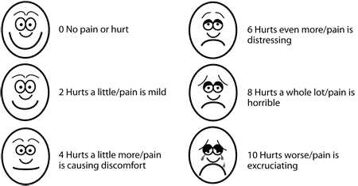

During Procedure
Analgesia used | Sedation | Side effects | Emergency Y/N | Monitoring

Post procedure

- How much pain did you experience during the procedure?

- Did you experience any side effects as the result of the pain relief/ sedation medication? Y/N
If yes, please specify:

- Would you have liked if more pain relief/sedation was used during your procedure? Y/N Please specify which one.

