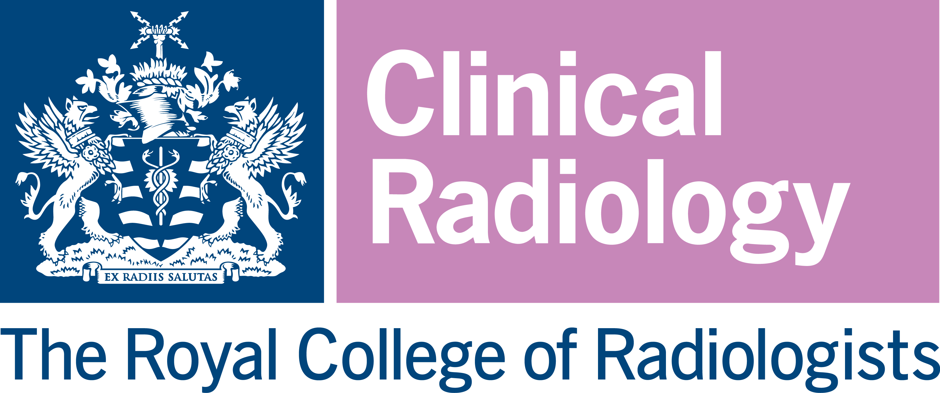

2023 KODAK FELLOWSHIP

Applications are invited from Members and Fellows of the Faculty of Clinical Radiology of the Royal College of Radiologists for a grant scheme of up to £65,000. The scheme is open to radiologists-in-training, early-mid career NHS consultants within ten years of completion of training to develop their research, or NHS consultants at any stage but new to research who hope to gain research experience.

The Scholarship is intended toward supporting research activity, for example, for a scientific and educational research project in the United Kingdom or abroad and may be used to assist the undertaking of a postgraduate degree e.g., PhD, MD(Res).

The area of research is not restricted; although it is expected that it will have direct relevance to the development or practice of, or education in, clinical radiology.

Funding may go towards, payment of the degree course, part funding of the applicant’s salary, or PAs for research. Any equipment costs of more than £1000 should have clear justification regarding why this is not already available within the institute where the research is being conducted. Funding may be used to support project related patient and public involvement events. Costs for supervision (supervisor salary) are not funded.

Due note will be taken of other sources of funding obtained by applicants. Applicants are encouraged to obtain some matched funding for their proposed project.

The grant will be awarded in instalments and will be contingent upon the receipt of the interim reports. At the end of the grant, the successful applicant(s) will be required to render a report to the Royal College of Radiologists.

The College shall hold and process all personal data received by it in connection with the Fellowship in accordance with the Data Protection Act 2018.
Please note that an applicant may apply for only ONE of the following awards in any given year: Kodak Fellowship, Constance Thornton Fellowship; RCR Seed Grant; and Research Bursary. The assessment panel reserves the right to move an application into another award category if appropriate.

Applications should comprise:
- A completed application form. The application form must be completed electronically and submitted by email.

The application form requires:

    - Details of the proposed project including title, purpose, timing, plan of investigation, methods, and techniques of study
    - Details of any co-applicants
    - Details of public and patient involvement
    - A budget plan
    - Details of two referees, both of which should be consultant clinical radiologists based at different institutions to each other and the applicant. The referees should be experts in their field and have no connection to either the project or the applicant(s). The referees will be asked to provide external feedback on the merits of the proposed project, NOT the character of the applicant.

- A brief curriculum vitae comprising of 2 pages maximum. This should NOT include a photograph of the applicant.

- Letter(s) of support from the research venue and/or project supervisor

- Gantt chart for project (if applicable)

Application and Assessment Procedure

• Applications should be sent by email to research@rcr.ac.uk to arrive not later than 5pm on
Friday 14th July 2023.
• An assessment panel nominated by the Royal College of Radiologists will consider applications. The decision of the assessment panel is final and binding.

• It is intended that the assessors’ recommendations will be reported to the Academic Committee meeting in September 2023 for approval. Applicants will be informed of the outcome of their application in early October 2023.

