Title
Re-audit of the quality of new patient history (NPH) dictations in the oncology department; improvements with individual feed-back.

Authors
Dr C Harrington, Dr D Mitchell, Dr J McAleese

Background
New patient histories (NPH) are dictated on first presentation of a patient into the oncology system. Their quality is therefore of key importance.

Aim
To assess both the quality and length of NPH dictations for the department and individuals.

Standards
Agreed departmental standards were used. The NPH should be 55 lines or less. Stage and performance status should be available in 80% of NPH. Treatment intent, drug allergies and management plan should be in all (100%).

Methods
Retrospective computer-record review for NPH for Lung and Urology groups in 2011. An audit proforma was constructed to give a global score of 100; dividing 10 points in each of the domains- stage, performance status, drug history, past medical history, examination, social history, family history, management plan, treatment intent and GP letter. After the audit, feedback was given to individuals. Re-Audit of NPH in 2012 presented here.

Results
7 urology consultants and 6 lung consultants were audited.
2011 overall quality was good(see table). In 2012 most doctors had shown improvements and overall there was an improvement in the quality indicators (p=0.05). Length of dictation shortened (p=0.007)

Standard | Target | 2011 ALL | 2012 ALL  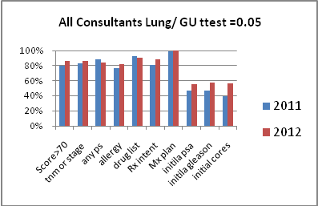
N |  | 136 | 110
Length (lines) | <55 lines | 61 | 48
Overall Score > 70 | 75% of NPH | 80% | 86%
AJCC stage or full TNM | 80% of NPH | 83% | 86%
Performance Status (PS) recorded | 80% of NPH | 89% | 85%
Drug Allergies recorded | 100% NPH | 77% | 82%
Treatment Intent Recorded | 100% NPH | 81% | 88%
Management Plan recorded | 100% NPH | 99% | 100%

Conclusions
An assessment of the quality of dictation can be undertaken. Individual feedback has a positive role in improving standards.

Actions
Expand the audit to include all oncology consultants. Expand the audit to look at other information areas (such as the documentation of prognosis). Increase the target rates for performance status and stage.

