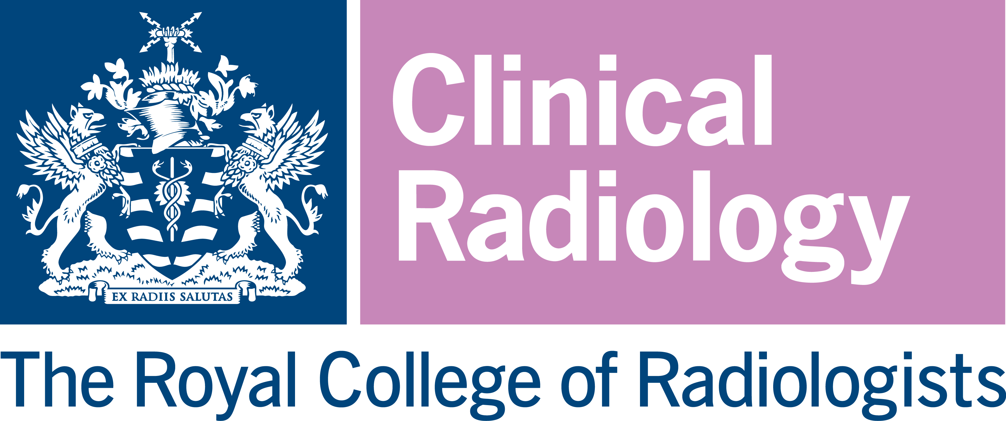

2023 CONSTANCE THORNTON FELLOWSHIP

Applications are invited from Members and Fellows of the Faculty of Clinical Radiology of the Royal College of Radiologists for a grant scheme of £3,000. The Fellowship is open to clinical radiologists holding appointments in the United Kingdom.

The Fellowship is intended for a research project or furthering a radiological interest in the United Kingdom or abroad.

Preference will be given to applications centred either on cross-sectional imaging or paediatric radiology, and especially to projects likely to lead to publication.

Funding may go towards research costs and/or accommodation/travel to another centre to conduct ethically approved research or to acquire a new radiological skill.

Due note will be taken of other sources of funding obtained by applicants.

At the end of the fellowship, the successful applicant(s) will be required to render a report to the Royal College of Radiologists.

The College shall hold and process all personal data received by it in connection with the Fellowship in accordance with the Data Protection Act 2018.
Please note that an applicant may apply for only ONE of the following awards in any given year: Constance Thornton Fellowship, Kodak Fellowship, RCR Seed Grant, and Research Bursary. The assessment panel reserves the right to move an application into another award category if appropriate.

Applications should comprise:
- A completed application form. The application form must be completed electronically and submitted by email.

The application form requires:

    - Details of the proposed project including title, purpose, timing, plan of investigation, methods, and techniques of study
    - Details of any co-applicants
    - Details of public and patient involvement
    - A budget plan
    - Details of two potential referees, both of which should be consultant clinical radiologists based at different institutions to each other, and to the applicant. The referees should be experts in their field and have no connection to either the project or the applicant(s). The referees will be asked by the RCR to provide external feedback on the merits of the proposed project, NOT the character of the applicant.

- A brief curriculum vitae comprising of 2 pages maximum. This should NOT include a photograph of the applicant.

- Letter(s) of support from the research venue and/or project supervisor

Application and Assessment Procedure

• Applications should be sent by email to research@rcr.ac.uk to arrive not later than 5pm on
Friday 14th July 2023.
• An assessment panel nominated by the Royal College of Radiologists will consider applications. The decision of the assessment panel is final and binding.

• It is intended that the assessors’ recommendations will be reported to the Academic Committee meeting in September 2023 for approval. Applicants will be informed of the outcome of their application in early October 2023.

