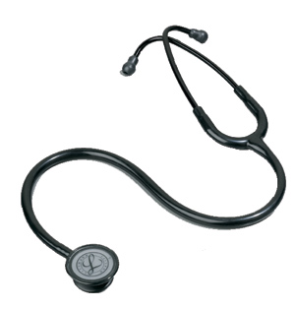
Attention All Doctors
Did you know....?
- ONE Abdomen X-ray has an equivalent dose of radiation as 35 Chest X-rays
- AXRs are not indicated for non specific abdominal pain
Examples of inappropriate AXR requests:
- RIF pain ?cause
- RUQ pain ?cause
- Epigastric pain ?cause
- Renal colic
- Sepsis ?cause
- Abdominal mass
Recommended indications for AXR:
- Clinical suspicion of bowel obstruction
- Ingestion of sharp or potentially poisonous foreign body
- Missing IUCD
- Post Gastrografin follow through study

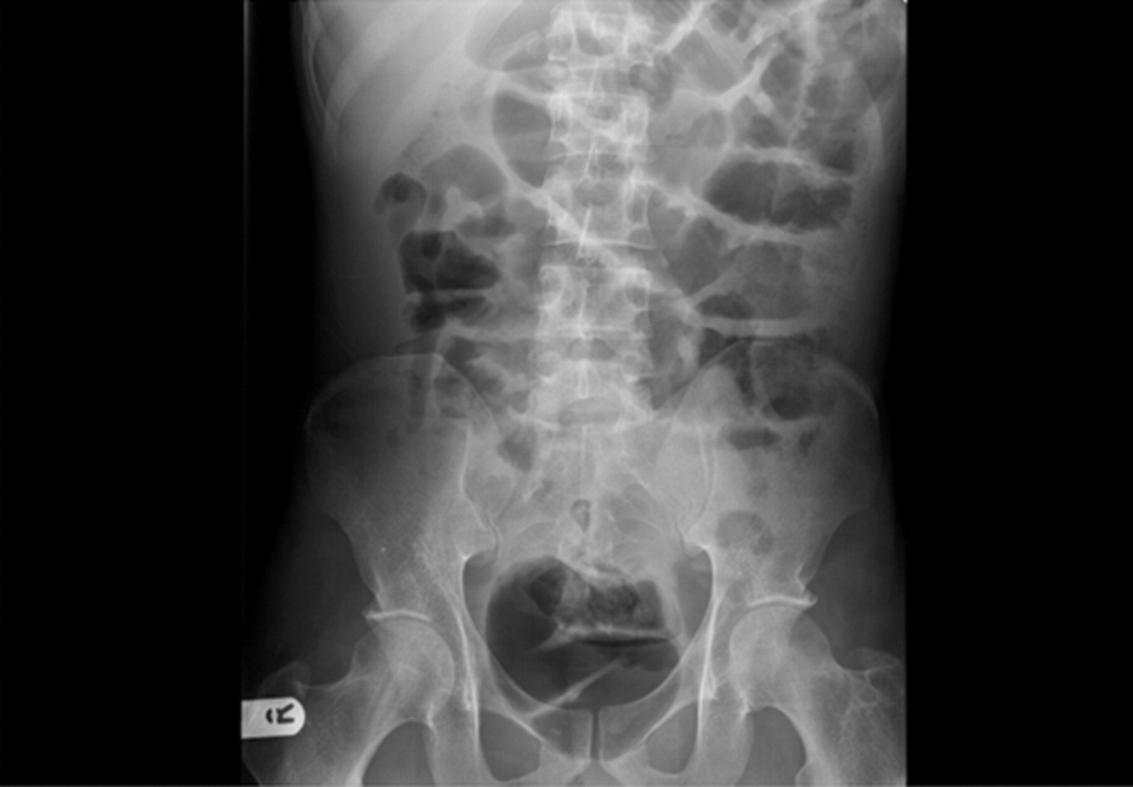
In abdomen pain without clinical suspicion of bowel obstruction:
- AXR is not usually indicated
- Consider USS, erect CXR, CT KUB or CT abdomen as first line imaging modality – please discuss with senior
- If AXR requested by surgeons – please indicate this on request form

The radiology department will only accept Abdomen X-ray requests for the above indications and only when the patient is referred from a Consultant or Registrar.

